**Assignment 3**

**Part 2: Implementing And Analyzing Cache Configurations in Gem5**

**Environment Setup and Install Dependencies:**

At the very beginning, dependencies like Python, SCons, GCC compilers etc. are installed to build and run gem5.

Once the environment is ready, the setup of the Gem5 simulator is initiated by cloning the Gem5 repository.

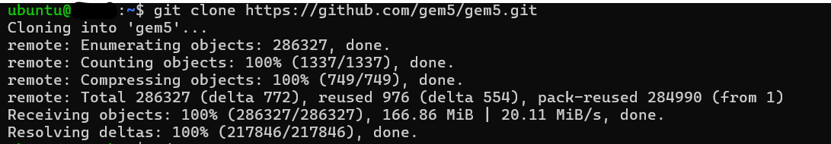

After the successful cloning, the building gem5 for x86 with the following code started which provided the following outcome.

scons build/X86/gem5.opt -j4

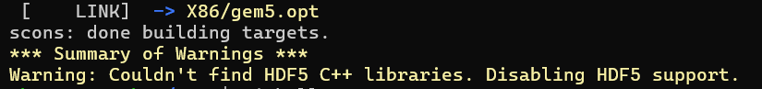

After that, the "Hello World" program is written in C language and saved it as ‘hello.c’.

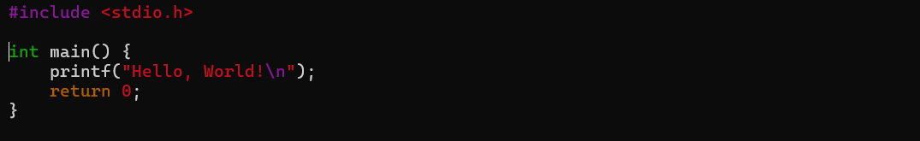

The written program is first compiled with the GCC compiler.



Later on, a Python program was created with the name ‘run_hello.py’ where all of the required architectural configurations are defined. Within it, the system will be called where the clock speed and voltage are called. Thereafter, the memory is configured and provided 512 MB of space to run the code. Then the CPU, memory unit and workload have been initialized to make the run of the C program successful.

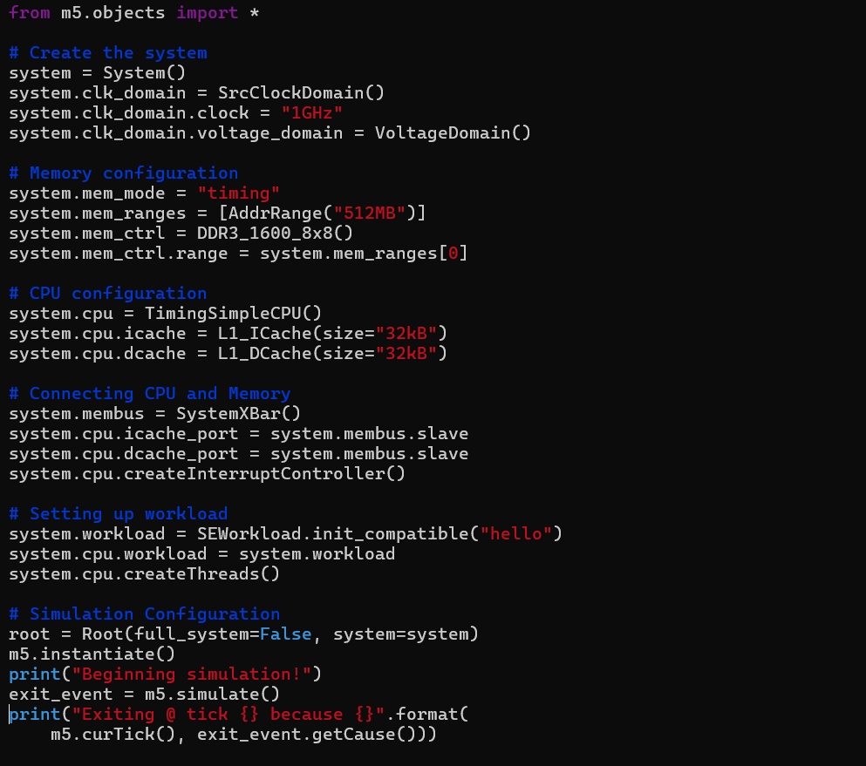

Finally, the execution of the configuration script will run will the following script that ultimately provides the outcome of the written C program.

./build/X86/gem5.opt configs/deprecated/example/se.py -c hello

Finally, the Python code for the simulation runs with the following command.

